Functional Models
“SecureIntent: Offline Cybersecurity Governance for Secure Automation Execution”
Divakar Saragadam, Systems Analyst
February 10, 2026

- Use Case Diagram
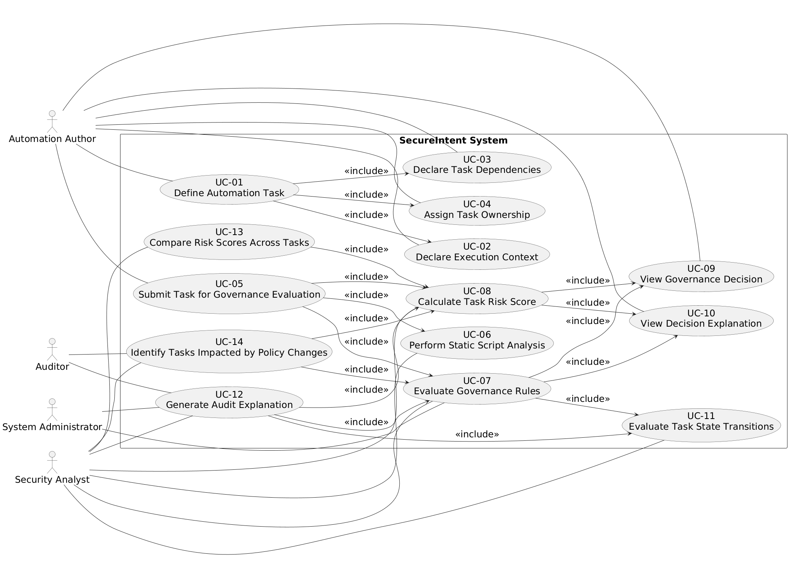
Diagram 1: Use Case Diagram for “SecureIntent: Offline Cybersecurity Governance for Secure Automation System”
- Use Case Description
Use Case - 1
Use Case Name: Define Automation Task |  | ID:UC-1 | Importance Level: High
Primary Actor: Automation Author | Use Case Type: Business
Stakeholders and Interests: The Automation Author is interested in clearly defining the intent, scope, and context of an automation task so that it can be evaluated and approved. Security Analysts rely on accurate task definitions to perform governance, risk, and compliance evaluations. The organization has an interest in ensuring that automation tasks are well defined in order to reduce cybersecurity, operational, and accountability risks.
Brief Description: This use case describes how an Automation Author defines a new automation task by providing its intent, execution context, dependencies, and ownership information so that the task can later be evaluated for cybersecurity governance compliance.
Trigger: The Automation Author decides to create a new automation task.
Type: External
Relationships:
Association: Automation Author
Include: Use Case 2 – Declare Execution Context, Use Case 3 – Declare Task Dependencies, Use Case 4 – Assign Task Ownership
Extend: None
Generalization: None
Normal Flow of Events:
- The Automation Author initiates the creation of a new automation task.
- The system prompts the Automation Author to enter task intent and business purpose.
- The Automation Author provides the required task intent information.
- The system records the task as a draft automation task.
- The system invokes Use Case 2 – Declare Execution Context.
- The system invokes Use Case 3 – Declare Task Dependencies.
- The system invokes Use Case 4 – Assign Task Ownership.
- The system saves the completed automation task definition.
SubFlows:
S-1: If any required task information is missing, the system prompts the Automation Author to provide the missing data before saving the task.
Alternate/Exceptional Flows:
- A-1: If the Automation Author cancels task creation, the system discards the task definition and no automation task is saved.

The above use case description is covering the requirements – 1, 3, 4, 5, 6
Use Case - 2
Use Case Name: Declare Execution Context |  | ID:UC-2 | Importance Level: High
Primary Actor: Automation Author | Use Case Type: Business
Stakeholders and Interests: The Automation Author is interested in declaring the execution privileges, timing constraints, and expected resource usage of an automation task so that it accurately reflects how the task is intended to operate. Security Analysts rely on this execution context information to evaluate least-privilege compliance, execution timing policies, and potential security risks. The organization has an interest in ensuring that automation tasks clearly specify execution conditions to reduce misuse, privilege escalation, and operational impact.
Brief Description: This use case describes how an Automation Author specifies the execution context for an automation task, including required privileges, execution timing constraints, and expected resource usage, so that the task can be evaluated for cybersecurity governance compliance.
Trigger: The Automation Author chooses to declare or update the execution context for an automation task.
Type: External
Relationships:
Association: Automation Author
Include: None
Extend: None
Generalization: None
Normal Flow of Events:
- The Automation Author selects an existing automation task.
- The system prompts the Automation Author to enter execution context details.
- The Automation Author specifies required execution privileges for the task.
- The Automation Author defines execution timing constraints for the task.
- The Automation Author declares expected resource usage for the task.
- The system validates the execution context information.
- The system saves the execution context for the automation task.
SubFlows:
S-1: If execution context information is incomplete or invalid, the system prompts the Automation Author to correct the information before saving.
Alternate/Exceptional Flows:
A-1: If the Automation Author cancels the operation, the system does not update the execution context and returns to the previous state.

The above use case description is covering the requirements – 2

Use Case - 3
Use Case Name: Declare Task Dependencies |  | ID:UC-3 | Importance Level: Medium
Primary Actor: Automation Author | Use Case Type: Business
Stakeholders and Interests:
The Automation Author is interested in declaring dependencies between automation tasks so that execution order, prerequisites, and inter-task relationships are clearly defined. Security Analysts rely on dependency information to evaluate risk propagation, cascading failures, and policy impacts across related tasks. The organization has an interest in understanding how automation tasks depend on one another in order to reduce systemic risk, prevent unintended execution sequences, and improve governance visibility.
Brief Description: This use case describes how an Automation Author defines dependencies between automation tasks by identifying prerequisite and related tasks so that dependency-based governance and risk analysis can be performed.
Trigger: The Automation Author chooses to declare or update dependencies for an automation task.
Type: External
Relationships:
Association: Automation Author
Include: None
Extend: None
Generalization: None
Normal Flow of Events:
- The Automation Author selects an existing automation task.
- The system displays available automation tasks that can be defined as dependencies.
- The Automation Author identifies one or more prerequisite or related tasks.
- The Automation Author specifies the dependency relationship for each selected task.
- The system validates the dependency definitions.
- The system records the declared task dependencies.
SubFlows: S-1: If an invalid or circular dependency is detected, the system prompts the Automation Author to revise the dependency definitions.
Alternate/Exceptional Flows: A-1: If the Automation Author cancels the operation, the system does not save dependency changes and returns to the previous state.

The above use case description is covering the requirements – 7

Use Case - 4
Use Case Name: Assign Task Ownership |  | ID:UC-4 | Importance Level: High
Primary Actor: Automation Author | Use Case Type: Business
Stakeholders and Interests: The Automation Author is interested in assigning clear ownership responsibility to an automation task so that accountability for task creation, maintenance, and compliance is established. Security Analysts and Auditors rely on ownership information to trace accountability and responsibility for automation decisions and outcomes. The organization has an interest in ensuring that every automation task has a clearly identified owner to support governance, auditing, and risk management.
Brief Description: This use case describes how an Automation Author assigns ownership responsibility to an automation task by identifying the individual or role accountable for the task.
Trigger: The Automation Author chooses to assign or update ownership for an automation task.
Type: External
Relationships:
Association: Automation Author
Include: None
Extend: None
Generalization: None
Normal Flow of Events:
- The Automation Author selects an existing automation task.
- The system prompts the Automation Author to assign an owner for the task.
- The Automation Author identifies the individual or role responsible for the task.
- The system validates the ownership information.
- The system records the assigned task ownership.
SubFlows:
S-1: If ownership information is missing or invalid, the system prompts the Automation Author to provide valid ownership details before saving.
Alternate/Exceptional Flows:
A-1: If the Automation Author cancels the operation, the system does not update ownership information and returns to the previous state.

The above use case description is covering the requirements – 2

Use Case - 5
Use Case Name: Submit Task for Governance Evaluation |  | ID:UC-5 | Importance Level: High
Primary Actor: Automation Author | Use Case Type: Business
Stakeholders and Interests: The Automation Author is interested in submitting a completed automation task for cybersecurity governance evaluation to determine if it meets organizational policies and security standards. Security Analysts rely on submitted tasks to perform static analysis, rule evaluation, and risk scoring. The organization has an interest in ensuring that only compliant tasks are executed, reducing operational and security risks and maintaining accountability and auditability.
Brief Description: This use case describes how an Automation Author submits a completed automation task to the system for governance evaluation, triggering analysis of script content, rule compliance, and risk assessment.
Trigger: The Automation Author completes task definition and chooses to submit the task for governance evaluation.
Type: External
Relationships:
Association: Automation Author
Include: Use Case 6 – Perform Static Script Analysis, Use Case 7 – Evaluate Governance Rules, Use Case 8 – Calculate Task Risk Score
Extend: None
Generalization: None
Normal Flow of Events:
- The Automation Author selects a completed automation task.
- The system validates that the task definition is complete.
- The Automation Author submits the task for governance evaluation.
- The system invokes Use Case 6 – Perform Static Script Analysis on associated scripts.
- The system invokes Use Case 7 – Evaluate Governance Rules to check policy compliance.
- The system invokes Use Case 8 – Calculate Task Risk Score.
- The system stores evaluation results and updates task status.
SubFlows:
S-1: If the task definition is incomplete, the system prompts the Automation Author to complete all required information before submission.
Alternate/Exceptional Flows:
A-1: If the Automation Author cancels the submission, the system does not perform any evaluation and keeps the task in a draft state.

The above use case description is covering the requirements – 8, 39, 40

Use Case - 6
Use Case Name: Perform Static Script Analysis |  | ID:UC-6 | Importance Level: High
Primary Actor: Security Analyst | Use Case Type: Business
Stakeholders and Interests: The Security Analyst is interested in performing static analysis of Python scripts associated with an automation task to identify sensitive operations, potential policy violations, and security risks without executing the scripts. Automation Authors rely on the analysis to understand compliance issues and improve their task definitions. The organization has an interest in preventing insecure or non-compliant automation from being executed, thereby reducing operational and security risks.
Brief Description: This use case describes how a Security Analyst (or system acting on their behalf) analyzes Python scripts using static analysis techniques, such as abstract syntax tree (AST) inspection, to detect sensitive operations and potential governance violations before execution.
Trigger: A task has been submitted for governance evaluation, or the Security Analyst requests script analysis for a specific task.
Type: External
Relationships:
Association: Security Analyst
Include: None
Extend: None
Generalization: None
Normal Flow of Events:
- The system receives a submitted automation task.
- The system retrieves all Python scripts associated with the task.
- The system performs static analysis using AST inspection to identify sensitive operations.
- The system identifies any potential policy violations in the scripts.
- The system generates a report of findings and alerts the Security Analyst.
- The system stores analysis results for later use in risk evaluation.
SubFlows:
S-1: If a script contains syntax errors or is malformed, the system reports the issue to the Security Analyst and skips the affected sections.
Alternate/Exceptional Flows:
A-1: If the Security Analyst cancels the analysis process, the system halts execution and retains partial analysis results if available.

The above use case description is covering the requirements – 12

Use Case - 7
Use Case Name: Evaluate Governance Rules |  | ID:UC-7 | Importance Level: High
Primary Actor: Security Analyst | Use Case Type: Business
Stakeholders and Interests: The Security Analyst is interested in evaluating submitted automation tasks against cybersecurity governance rules to ensure compliance with least-privilege principles, execution timing restrictions, separation of duties, and other organizational policies. Automation Authors rely on this evaluation to understand whether their tasks meet compliance standards. The organization has an interest in enforcing policies to reduce security risks, maintain accountability, and produce reliable audit trails for all automation activities.
Brief Description: This use case describes how a Security Analyst evaluates an automation task against pre-defined governance rules, including checking declared privileges, execution timing constraints, dependencies, and policy thresholds, to determine if the task is approved or rejected.
Trigger: A task has been submitted for governance evaluation, or the Security Analyst initiates a governance review.
Type: External
Relationships:
Association: Security Analyst
Include: Use Case 6 – Perform Static Script Analysis, Use Case 8 – Calculate Task Risk Score
Extend: None
Generalization: None
Normal Flow of Events:
- The system receives a submitted automation task.
- The system retrieves the task’s execution context, dependencies, and script analysis results.
- The system evaluates the task against all active governance rules, including least-privilege, timing constraints, and separation-of-duties rules.
- The system flags any violations of governance policies.
- The system invokes Use Case 8 – Calculate Task Risk Score to quantify the task’s risk.
- The system produces an evaluation result indicating approval, rejection, or required revisions.
- The system records the evaluation results for audit and accountability purposes.
SubFlows:
S-1: If governance rules are updated during evaluation, the system uses the latest active rules for compliance checks.
Alternate/Exceptional Flows:
A-1: If the Security Analyst cancels the evaluation process, the system halts processing and marks the task as pending evaluation.

The above use case description is covering the requirements – 11, 13, 14, 15
Use Case - 8
Use Case Name: Calculate Task Risk Score |  | ID:UC-8 | Importance Level: High
Primary Actor: Security Analyst | Use Case Type: Business
Stakeholders and Interests: The Security Analyst is interested in quantifying the risk associated with an automation task to provide a clear, objective measure of potential security, operational, and compliance impacts. Automation Authors rely on the risk score to understand task vulnerabilities and areas requiring adjustment. The organization has an interest in prioritizing review and mitigation of higher-risk tasks to reduce security incidents, enforce governance policies, and maintain accountability.
Brief Description: This use case describes how a Security Analyst calculates a risk score for an automation task based on static script analysis, declared execution context, task dependencies, and governance rule violations. The score helps determine whether the task should be approved, rejected, or revised.
Trigger: A task has been submitted for governance evaluation, or a Security Analyst initiates risk scoring.
Type: External
Relationships:
Association: Security Analyst
Include: None
Extend: None
Generalization: None
Normal Flow of Events:
- The system receives the submitted automation task and its evaluation data.
- The system retrieves static analysis results, execution context, and dependency information.
- The system applies risk scoring algorithms to evaluate the task’s potential security and operational impact.
- The system aggregates policy violations, dependency risks, and privilege concerns to compute a composite risk score.
- The system records the risk score in the task record.
- The system provides the risk score to the Security Analyst and updates the governance evaluation result.
SubFlows: S-1: If incomplete evaluation data is detected, the system prompts the Security Analyst to review missing elements before calculating the risk score.
Alternate/Exceptional Flows:
- A-1: If the Security Analyst cancels the scoring process, the system halts calculation and leaves the task in a pending-risk-score state.

The above use case description is covering the requirements – 16

Use Case - 9
Use Case Name: View Governance Decision |  | ID:UC-9 | Importance Level: High
Primary Actor: Automation Author | Use Case Type: Business
Stakeholders and Interests: The Automation Author is interested in viewing the governance decision for a submitted task to understand whether it has been approved, rejected, or requires revision. Security Analysts rely on this process to communicate evaluation outcomes clearly. The organization has an interest in ensuring transparency, accountability, and timely feedback on task compliance to maintain governance standards and reduce operational risk.
Brief Description: This use case describes how an Automation Author retrieves and reviews the governance decision of a submitted automation task, including whether it passed evaluation, was rejected, or needs modifications.
Trigger: The Automation Author chooses to view the governance decision for a submitted automation task.
Type: External
Relationships:
Association: Automation Author
Include: Use Case 8 – Calculate Task Risk Score
Extend: None
Generalization: None
Normal Flow of Events:
- The Automation Author selects a submitted automation task.
- The system retrieves the governance evaluation results for the task.
- The system displays the decision (approved, rejected, or needs revision) to the Automation Author.
- The system provides summary information about the evaluation, including risk score and rule violations.
SubFlows:
S-1: If evaluation results are not yet available, the system informs the Automation Author that the task is still pending review.
Alternate/Exceptional Flows:
- A-1: If the Automation Author cancels the view operation, the system returns to the previous menu or dashboard without displaying decision information.

The above use case description is covering the requirements – 9, 16

Use Case - 10
Use Case Name: View Decision Explanation |  | ID:UC-10 | Importance Level: High
Primary Actor: Automation Author | Use Case Type: Business
Stakeholders and Interests: The Automation Author is interested in understanding why a submitted automation task was approved, rejected, or required revision. Security Analysts rely on clear explanations to communicate the rationale behind governance decisions. The organization has an interest in ensuring transparency and accountability, so Automation Authors can improve compliance and maintain clear audit trails for task evaluations.
Brief Description: This use case describes how an Automation Author retrieves detailed explanations for a governance decision, including rule violations, risk factors, and dependencies influencing the evaluation outcome.
Trigger: The Automation Author chooses to view the explanation for a governance decision of a submitted task.
Type: External
Relationships:
Association: Automation Author
Include: Use Case 7 – Evaluate Governance Rules, Use Case 8 – Calculate Task Risk Score
Extend: None
Generalization: None
Normal Flow of Events:
- The Automation Author selects a submitted automation task.
- The system retrieves the governance evaluation details for the task.
- The system displays a detailed explanation of the decision, including:
  - Which governance rules were applied
  - Policy violations detected
  - Calculated risk score
  - Dependency-based influences
- The Automation Author reviews the explanation to understand compliance and improvement areas.
SubFlows:
S-1: If detailed evaluation data is incomplete, the system indicates which elements are pending and provides partial explanations.
Alternate/Exceptional Flows:
A-1: If the Automation Author cancels the operation, the system does not display the explanation and returns to the previous menu or dashboard.

The above use case description is covering the requirements – 10, 7, 8
Use Case - 11
Use Case Name: Evaluate Task State Transitions |  | ID:UC-11 | Importance Level: Medium
Primary Actor: Security Analyst | Use Case Type: Business
Stakeholders and Interests: The Security Analyst is interested in evaluating state transitions of automation tasks to ensure that tasks follow proper lifecycle progression, from creation through submission, evaluation, approval/rejection, and potential resubmission. Automation Authors rely on state information to track their tasks’ progress and compliance status. The organization has an interest in maintaining controlled task states to enforce governance rules, prevent unauthorized actions, and provide clear auditability.
Brief Description: This use case describes how a Security Analyst reviews and evaluates the state transitions of an automation task, tracking changes from creation, submission, evaluation, and final decision, to ensure proper compliance with governance rules and lifecycle policies.
Trigger: A Security Analyst requests a review of the state transitions for a specific automation task.
Type: External
Relationships:
Association: Security Analyst
Include: None
Extend: None
Generalization: None
Normal Flow of Events:
- The Security Analyst selects a specific automation task.
- The system retrieves the task’s historical states, including creation, submission, evaluation, and approval/rejection.
- The system displays a timeline of state transitions.
- The Security Analyst reviews each transition for compliance with governance rules and policies.
- The system flags any unexpected or unauthorized transitions.
SubFlows: S-1: If state history is incomplete or missing entries, the system highlights gaps for review.
Alternate/Exceptional Flows:
A-1: If the Security Analyst cancels the operation, the system does not display state information and returns to the previous dashboard or menu.

The above use case description is covering the requirements – 17
Use Case – 12
Use Case Name: Generate Audit Explanation |  | ID:UC-12 | Importance Level: High
Primary Actor: Security Analyst | Use Case Type: Business
Stakeholders and Interests: The Security Analyst is interested in generating clear, detailed audit explanations for governance decisions to support accountability, traceability, and compliance verification. Auditors rely on these explanations to review decisions, verify adherence to policies, and produce reports. The organization has an interest in maintaining transparent audit trails to demonstrate proper governance and reduce operational and security risk.
Brief Description: This use case describes how a Security Analyst generates a detailed audit explanation for an automation task, including applied governance rules, risk assessment, dependency influences, and decision rationale.
Trigger: A Security Analyst or Auditor requests an audit explanation for a specific automation task.
Type: External
Relationships:
Association: Security Analyst
Include: Use Case 7 – Evaluate Governance Rules, Use Case 8 – Calculate Task Risk Score, Use Case 11 – Evaluate Task State Transitions
Extend: None
Generalization: None
Normal Flow of Events:
- The Security Analyst selects an automation task for audit explanation.
- The system retrieves governance evaluation results, state transition history, and risk scoring data.
- The system compiles a detailed explanation including:
  - Applied governance rules
  - Policy violations detected
  - Risk score and reasoning
  - State transition impacts
- The system displays the audit explanation to the Security Analyst and stores it for reporting and accountability.
SubFlows:
S-1: If any evaluation or state data is missing, the system flags gaps and provides a partial audit explanation.
Alternate/Exceptional Flows:
A-1: If the Security Analyst cancels the process, the system does not generate an audit explanation and returns to the previous view or dashboard.

The above use case description is covering the requirements – 18, 7, 8, 11
Use Case - 13
Use Case Name: Compare Risk Scores Across Tasks |  | ID:UC-13 | Importance Level: Medium
Primary Actor: Security Analyst | Use Case Type: Business
Stakeholders and Interests: The Security Analyst is interested in comparing risk scores of multiple automation tasks to identify high-risk tasks, spot trends, and prioritize governance actions. Automation Authors benefit from understanding how their tasks’ risk scores relate to others, enabling better compliance. The organization has an interest in focusing security and governance resources on the most critical or high-risk automation tasks to reduce operational and security risks.
Brief Description: This use case describes how a Security Analyst retrieves and compares the calculated risk scores of multiple automation tasks to support decision-making, prioritize interventions, and identify patterns of non-compliance.
Trigger: A Security Analyst requests to compare risk scores for multiple automation tasks.
Type: External
Relationships:
Association: Security Analyst
Include: Use Case 8 – Calculate Task Risk Score
Extend: None
Generalization: None
Normal Flow of Events:
- The Security Analyst selects multiple automation tasks for comparison.
- The system retrieves the risk scores for the selected tasks.
- The system displays a comparison table or chart of risk scores.
- The Security Analyst reviews high-risk tasks and trends.
- The system stores comparison results for audit and reporting purposes.
SubFlows:
S-1: If any selected task does not have a calculated risk score, the system prompts the Security Analyst to calculate scores first or excludes incomplete tasks.
Alternate/Exceptional Flows:
- A-1: If the Security Analyst cancels the operation, the system does not generate a comparison and returns to the previous dashboard or menu.

The above use case description is covering the requirements – 19, 8

Use Case - 14
Use Case Name: Identify Tasks Impacted by Policy Changes |  | ID:UC-14 | Importance Level: Medium
Primary Actor: Security Analyst | Use Case Type: Business
Stakeholders and Interests: The Security Analyst is interested in identifying automation tasks affected by recent changes in governance rules or security policies to ensure timely re-evaluation and maintain compliance. Automation Authors benefit by being informed of which of their tasks may require updates or resubmission. The organization has an interest in ensuring that all automation tasks remain compliant with current policies, preventing security incidents and maintaining accurate audit records.
Brief Description: This use case describes how a Security Analyst retrieves and identifies automation tasks that may be impacted due to recent policy or governance rule changes, enabling targeted review and re-evaluation.
Trigger: A Security Analyst applies a policy update or requests identification of tasks potentially impacted by recent policy changes.
Type: External
Relationships:
Association: Security Analyst
Include: Use Case 7 – Evaluate Governance Rules, Use Case 8 – Calculate Task Risk Score
Extend: None
Generalization: None
Normal Flow of Events:
- The Security Analyst selects a governance policy that has been updated.
- The system retrieves all automation tasks affected by the updated policy based on execution context, privileges, dependencies, and task attributes.
- The system flags impacted tasks and generates a report for the Security Analyst.
- The Security Analyst reviews flagged tasks and decides whether re-evaluation or updates are required.
- The system records the identification process and updates audit logs.
SubFlows:
S-1: If a task cannot be assessed due to missing evaluation data, the system marks it for manual review by the Security Analyst.
Alternate/Exceptional Flows:
- A-1: If the Security Analyst cancels the process, the system does not generate any impacted task list and returns to the previous dashboard or menu.

The above use case description is covering the requirements – 20, 7, 8

2. Activity Diagram
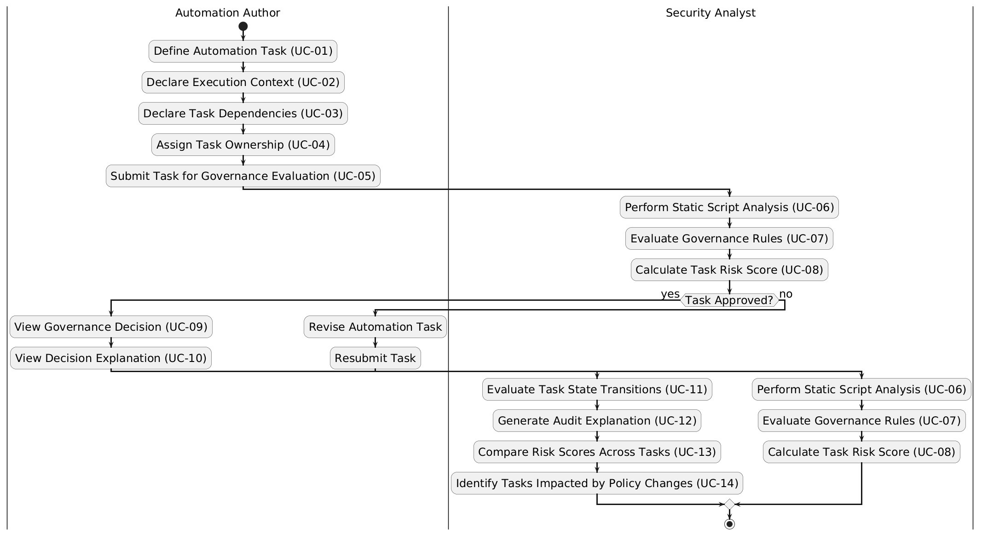
Diagram 3: Activity Diagram for “SecureIntent: Offline Cybersecurity Governance for Secure Automation System”

